­

GIS Volunteers Make a Difference One Map at a Time

Your Logo

Volunteer at the garden and join our team of fun and dedicated volunteers who provide hundreds of hours of service each week.

Previous GIS experience is a bonus, but not required.

To learn more about becoming a GIS Garden Inventory volunteer please contact:

Jane Smith

[janesmith@janesmith.com](mailto:janesmith@janesmith.com)

(xxx)-xxx-xxxx

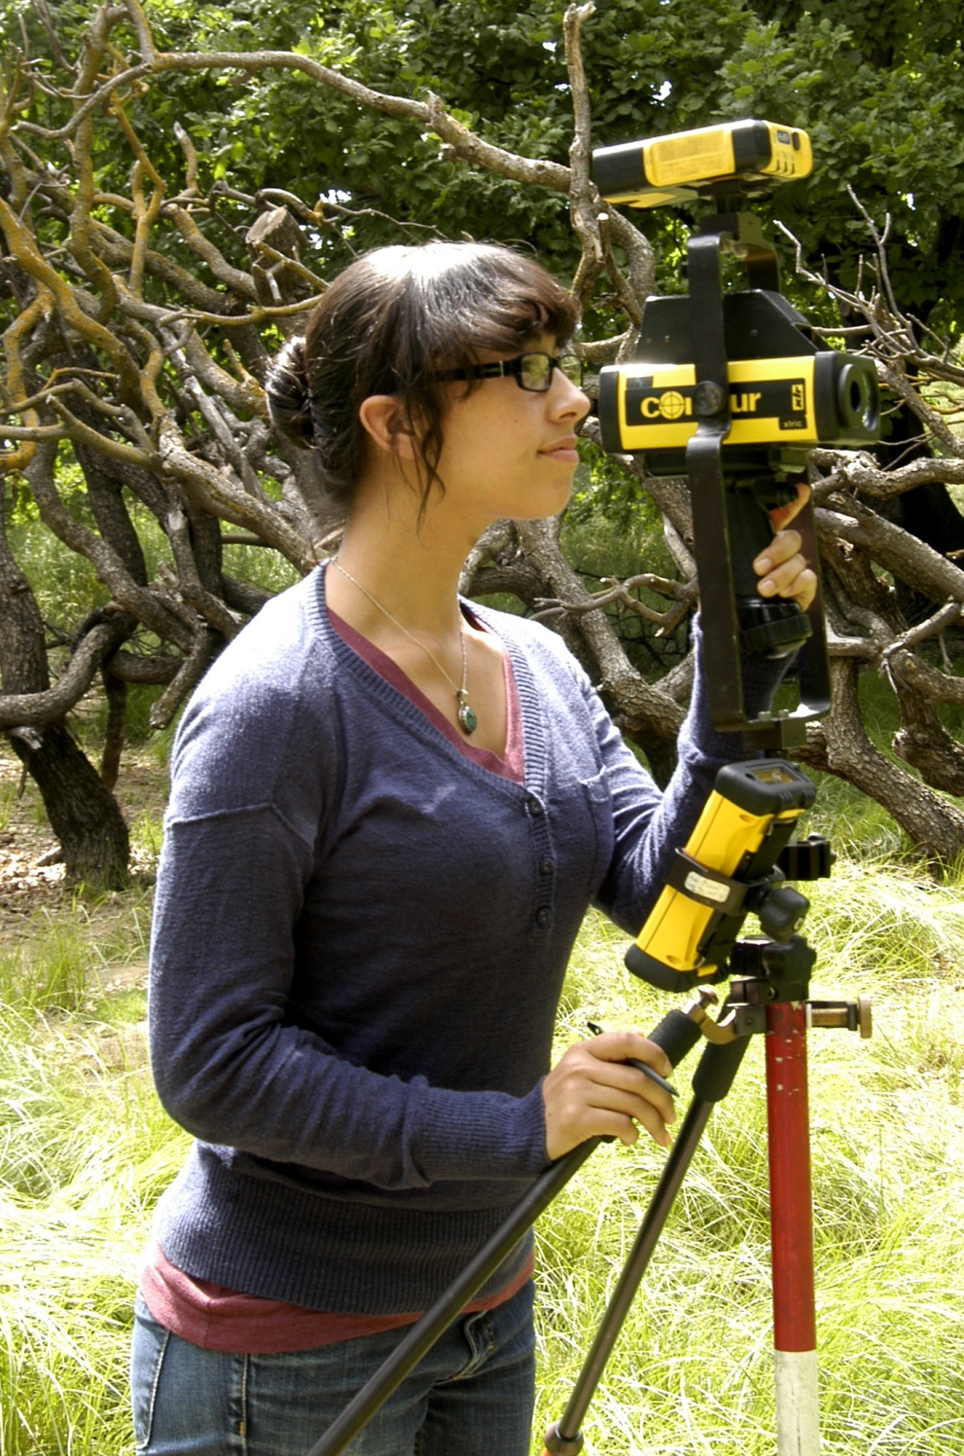

* Learn information about plants, plant names, and gain skills in plant identification
* Familiarize yourself with the garden collections on a detailed level
* Share/Develop your skills, make a difference, and connect with people of all ages