­

**GIS Volunteers Make a Difference One Map at a Time**

**Your Logo**

**Volunteer at the garden and join our team of fun and dedicated volunteers who.**

**Previous GIS experience is a bonus, but not required.**

.

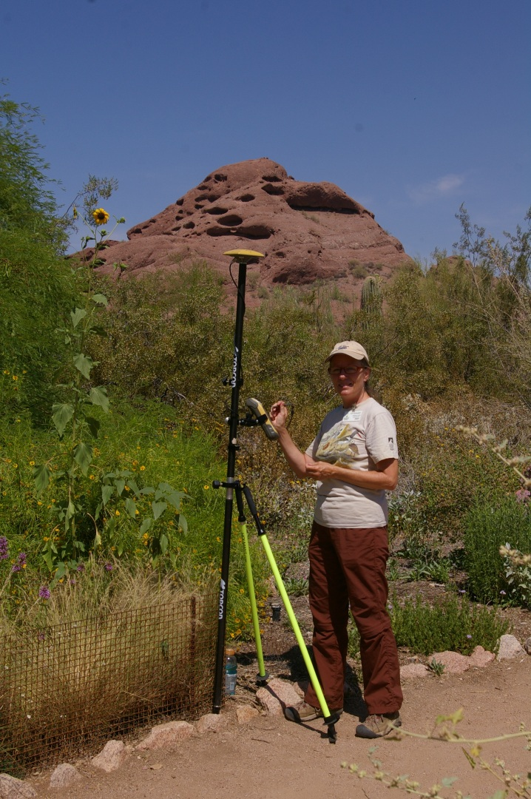

**To learn more about becoming a GIS Garden Inventory volunteer please contact:**

**Jane Smith**

[**janesmith@janesmith.com**](mailto:janesmith@janesmith.com)

**(xxx)-xxx-xxxx**

* **Learn information about plants, plant names, and gain skills in plant identification**
* **Familiarize yourself with the garden collections on a detailed level**
* **Share/Develop your skills and make a difference**
* **Meet a diverse range of people and become more connected to your community**
* **Broaden your horizons and connect to the natural world**